**WMS Order Screen**

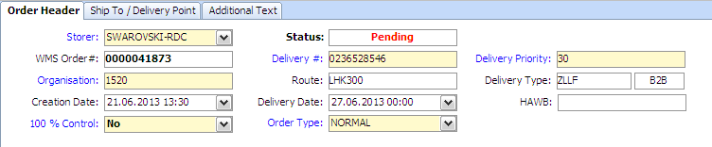

**SAP VL03n Screen**

